Dalton Murray

Human Computer Interaction

INT 3603 - 3452-202320_INT3603_OL

Professor Darren Hood

Sunday, April 16, 2022

**Lab 8 & Assignment 5**

(All images are accessible by Google Drive: <https://drive.google.com/drive/folders/1mG9ELUuzyw1dyQR6tF4kPutBXt3v8vBC?usp=share_link>)

**Lab 8**

The website which I have chosen to perform this week’s lab and assignment on is Land Rover. An image of the whole site’s landing page can be found below in the Images section. The landing page is also where I will be focusing my attention on when reviewing my selected heuristics from Abby Covert’s heuristic model. However, I will briefly look at other pages as well in order to ensure that my analysis of the website is complete.

The three heuristics which I have chosen to focus on to analyze this website from Abby Covert’s heuristics are as follows: Findable, Accessible, and Delightful. When looking at findable, it asks if people can locate what they are looking for, if they are able to do so across different channels and devices/findability is being affected, if there are multiple ways of accessing things, how search engines relate to the website (internal and external), information formatting, and how they make delivered results more useful. For accessible, it asks if it can be used by all expected channels and devices, how resilient and consistent the website is across all of the different channels, and how if it meets the levels of accessibility compliance.

Findable – I find some things difficult to find without having prior knowledge of the website and where everything is at. Many things seem to be buried within submenus of navigation and not easy to locate, especially since it doesn’t really seem to stand out. When looking at the website in a larger or smaller resolution, things become even more difficult to find, and when looking at the website on my phone it is vastly more difficult to find specific things, especially with how cluttered the page looks and feels. There are, however, multiple ways to find different things, but they are often either hidden or not obvious. When using internal search functions, it does seem to work well, as well as using external search engines. Information is what I would call half-way formatted to be with results in mind. Once you do get to where you want to be at, they have a number of ways of formatting to show you how to build your car or choose it in a decent way which is easily findable and understandable.

Accessible – This website makes using it on a larger monitor or resolution much more difficult to work with and makes a smaller resolution also difficult to work with. On a regular sized monitor (15.6 inch) it seems to look like it was made for that size and works best with it. In other words, no, it does not work well with all expected channels and devices. It also seems to prefer using Google Chrome over other web browsers because of errors reported in console and functionality. When looking at the website with another channel, such as my phone, it provides about the same level of functionality and consistency as the website on my computer, however, it is still low. When looking at the website running it through some accessibility tools, Google’s Lighthouse gives it a score of 88 (Images Section Lighthouse), and found some missing links with names, and some items without tab indexes, preventing a keyboard to be able to navigate through the page. aXe DevTools, however, found 24 total issues with the website (Images Section aXe DevTools), primarily being id attributes not being unique, scaling issues, links without text, and tab indexes.

Delightful – Looking at the delightfulness of the website, I can’t really say I am impressed in any way. There doesn’t seem to be much if not anything which differentiates it from other car manufacturers’ websites or much that makes it stand out. I wouldn’t really say the website exceeds any of my expectations, or even meets half of them. However, my expectations for websites today are very high.

**Overall Recommendations**

The landing page of the website needs to drastically change. They need a better color scheme, or even one at all because they don’t currently have one other than white and an incredibly light grey. They also need to fix all of their id attributes, links and tab indexes. They also need to make their website much easier to navigate and find content. The primary problem with this is the amount of stuff they put onto one page making it look and feel cluttered and overwhelming. They also need to fix their scaling with resolutions and how content is displayed on different monitor sizes/resolutions.

**Assignment 5**

For assignment 5, I decided to make a simple diagram/wireframe of what the website currently looks like, and what it should look like with my recommendations.

Existing website diagram:

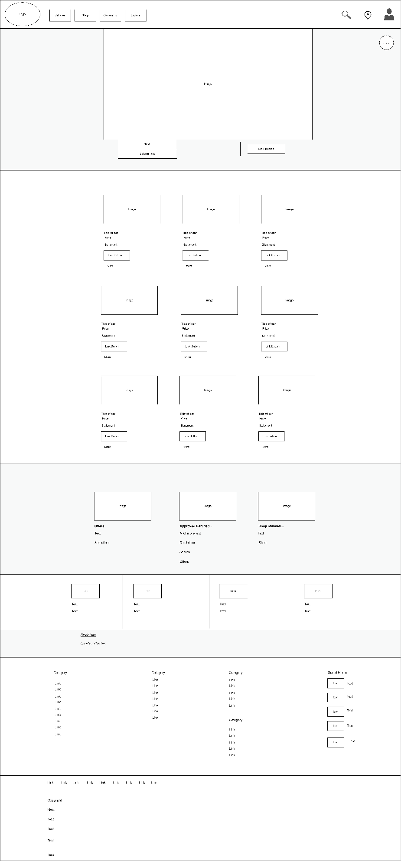

New website diagram with some of my suggestions:

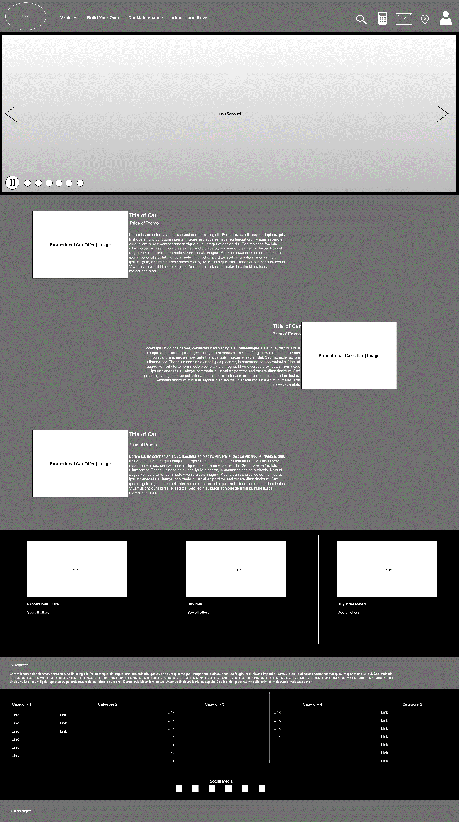

This new landing page increases the findability of the entire website. It eliminates a lot of wasted space for repeat content and uses space much better. It also makes the website stand out much more with a better color scheme. However, the color scheme could be improved a bit more to make the colors have a little less drastic of a change between divisions in the page. This new design also makes navigation much easier with more precise categories.

**Images**

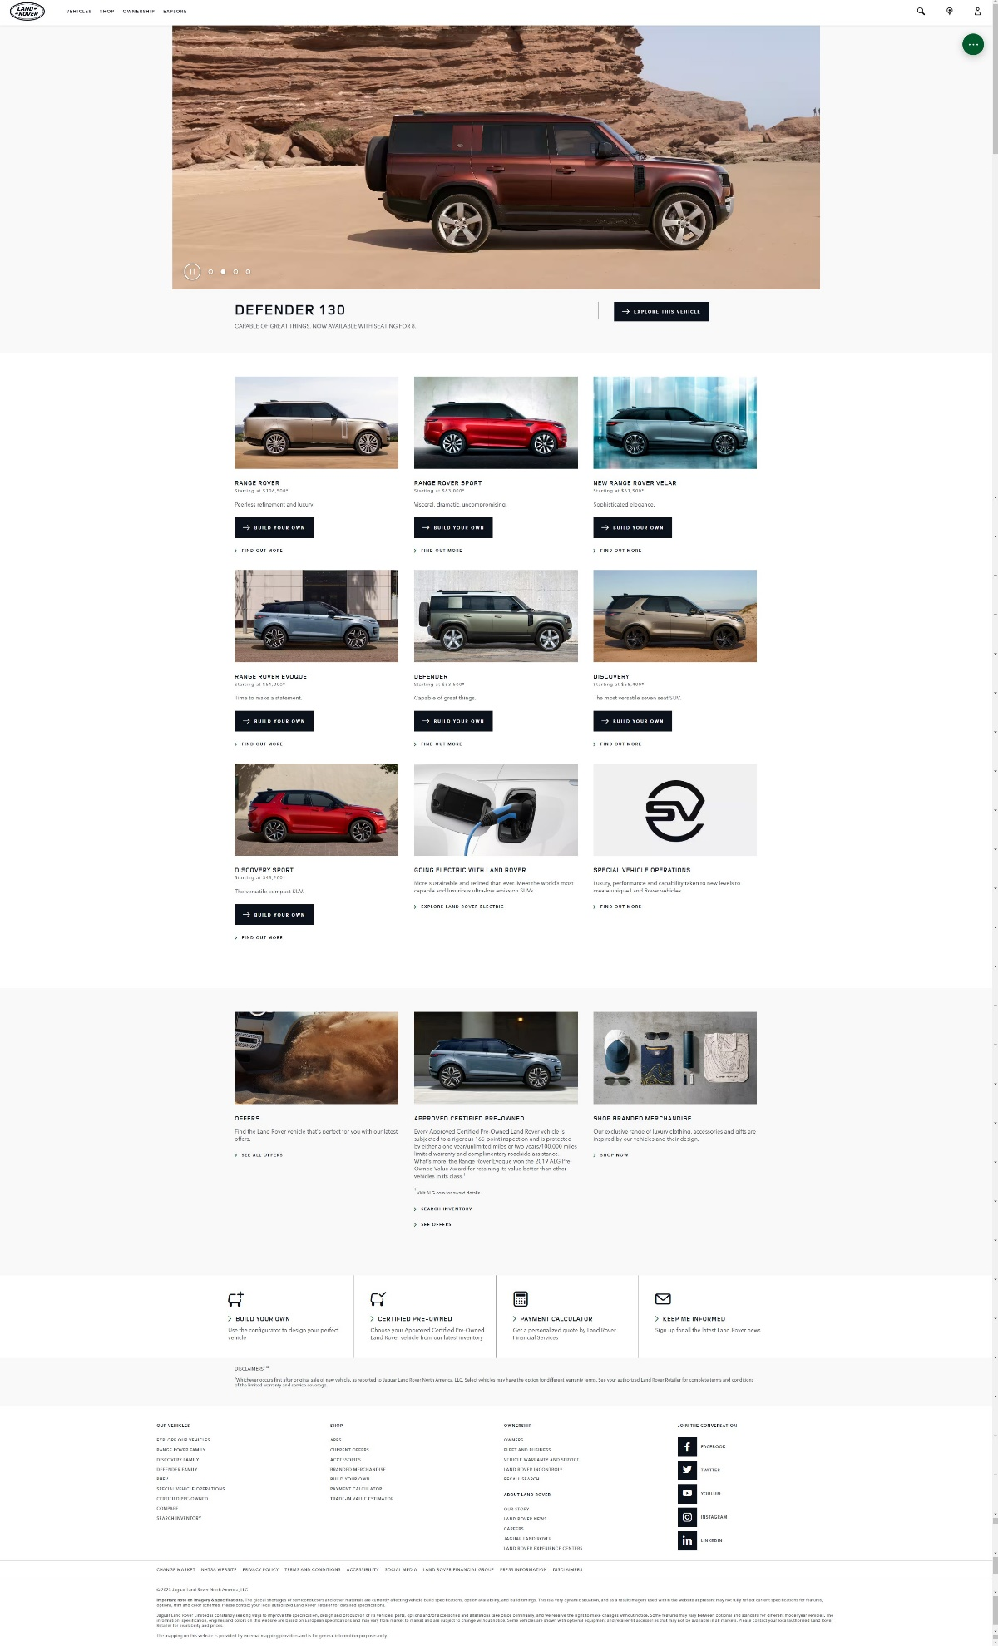

**(Landing Page)**

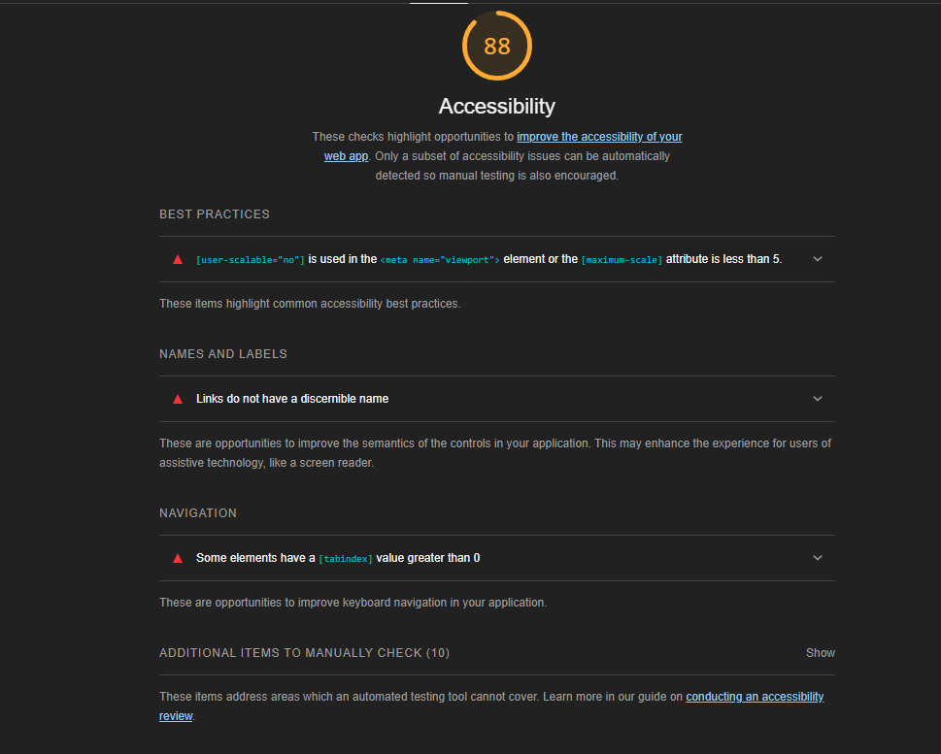

**(Google Lighthouse)**

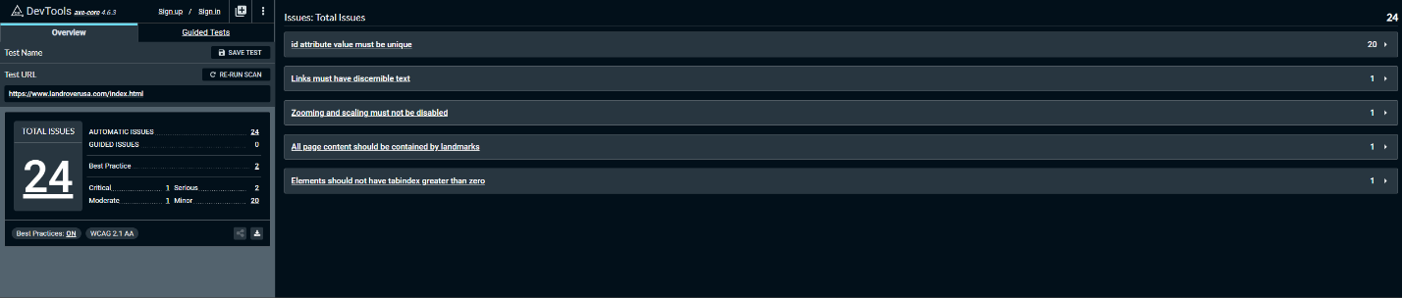

**(aXe DevTools)**

**References**

Kim, G. J. (2015). Human-Computer Interaction: Fundamentals and Practice. Auerbach.

I have neither given nor received unauthorized aid in completing this work, nor have I presented someone else's work as my own.

*Dalton Murray*